BIOC 455
Lecture # 16– Discussion of Article: 2
Lecturer: Dr. Tak Pan Wong – February 9, 2007

NOTE: This NTC is meant to be used as a study aid to supplement your own class notes. Hence, not all of the text or diagrams contained in the lecture slides will be reproduced here.

Please send any comments or questions about NTCs to either Wanda or James through e-mail at u3.represent@gmail.com .

Article: Mutation of GABRA1 in an autosomal dominant form of juvenile myoclonic epilepsy

Outline: The genes responsible for causing idiopathic generalized epilepsy (IGE) are unknown. Study reports that a Ala322Asp mutation in GABRA1, encodes alpha subunit of GABA_{A} has been found in family with IGE. GABA_{A} with mutated subunit have a lesser amplitude of GABA activated current, suggesting that seizures may result from loss of function in this inhibitory ligand gated channel. Study suggests that mutation in GABRA1 predisposes towards IGE.

Table 1 and Fig 1 were not discussed in class

Fig2:

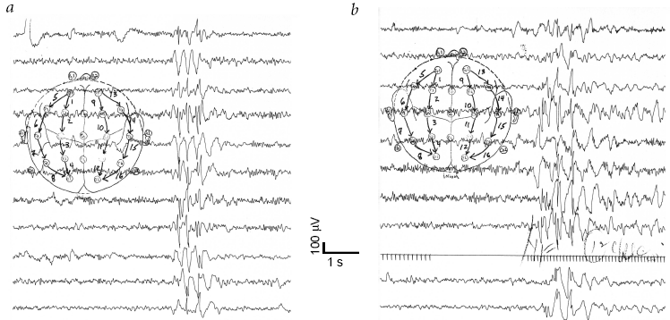

Fig 2 is an electroencephalogram (EEG) of an individual with IGE. The spheres with numbers represent the different points on the skull where electrodes are placed during the scan. Each line represents a different electrode, corresponding to a different point on the skull. Panel A shows the EEG for an individual during a spontaneous generalized seizure. The spikes correspond to epileptic discharges. Patients with IGE have simultaneous epileptic discharges originating from many points in the brain. This is why all of the spikes are synchronized in panel A. Panel A is a characteristic spike readout for a patient with generalized epilepsy. Comparatively in a patient with localized epilepsy the different traces would not be synchronized. Furthermore a normal patient would have a relatively flat line for each trace i.e. no epileptic discharge recorded. Panel B is an EEG reading for the same patient as in Panel A however the epilepsy is now caused by photic stimulation. These forms of seizures are triggered by stimulation by light. Professor mentioned cases of children expressing seizure upon playing certain videogames.

Fig 3:
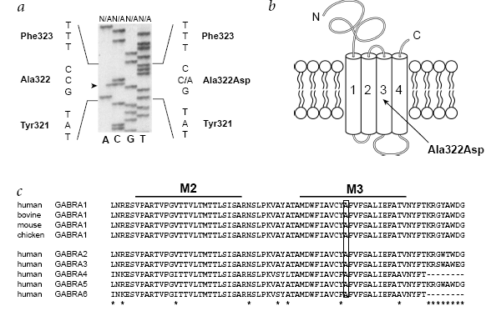
Fig 3 describes aspects of the mutation effecting GABRA1. Panel A shows a sequence analysis of PCR products amplified from genomic DNA. Each gel lane is separate into normal (N) and effected (A: mutated). It is important to take note that the mutation appears to occur at position 322, where cystosine is replaced by adenine. This leads to the presence of Asparagine as opposed to Alanine at position 322. The change in amino acids will greatly effect the functioning of the protein e.g. receptor. Panel B, shows that the mutation occurs in the middle of the third transmembrane domain of the channel. A mutation inside the transmembrane domain of an ion channels will greatly affect its ability to control passage of particular ions. Panel C shows that alanine at position 322 is a highly conserved domain of the protein. Ala322 arrangement is conserved across species and also in between GABA A α-subunit genes in humans.

Fig 4:
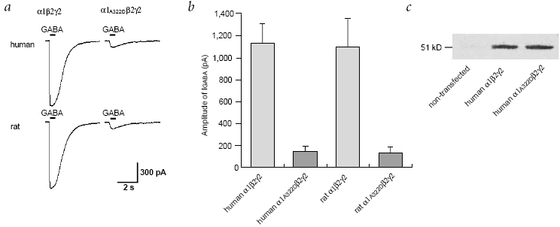

Fig 4 compares the behavior between a normal and mutated GABA A receptor. Panel A compares the current output between a normal and a mutated receptor. GABA A allows Cl into the cell. The peaks of these curves show much Cl is entering the cell. In the mutated form the top of the curve is much lower and therefore much less ions are entering Cl ions are entering the cell. Panel B is a more quantitative comparison of panel A. The top of each bar corresponds to the # of ions entering the cell in pA. In rats and humans Cl flow is very similar. Panel C is a comparative immunoblot analysis of proteins taken from normal and affected. This panel shows that the mutation does not alter expression of the GABA A receptor in the cell and therefore suggests a change in the functionality of the receptor. However, this quantitative analysis gives information about the [GABA A] in the entire cell and not just on the membrane. This is important because GABA A is only functional when it is on the synapse e.g. on the membrane. Therefore the possibility remains that the GABA A receptors simply are not reaching the membrane and are functionally normal. This possibility could have been studied had the researches used a surface biotination technique. Pairing this technique with a Western Blot Anaylsis allows you to find out the concentration of a particular protein on the surface of the membrane only. By using a protein (biotin) that cannot pass through the cell membrane only proteins on cell membrane are encoded. Avidin is a molecule which strongly binds to biotin. Washing of the cell sample with Avidin will only leave the biotin relevant proteins.

Fig 5:
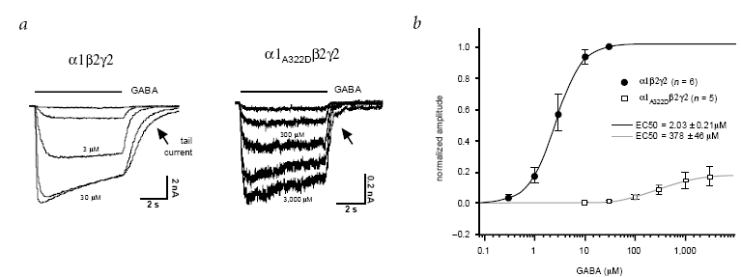
Fig 5 compares the binding affinity of mutated and normal GABA A receptors for neurotransmitter GABA. Panel A shows that the normal GABA A receptor response to 3 µM and than 30 µM. In the mutated form similar current output is only achieved at 300 and 3000 µM. This shows that it takes much more, 100x, GABA to activate the mutated form of the receptor. The time course of the currents does appear to be the same. Panel B looks at the dose response curve of the two receptors. EC50 is the concentration of ligand required for a receptor to reach ½ of its maximum function. EC50 of wild type, black line, is 2 µM where as EC50 of mutant is 400 µM e.g. almost 400x more. This figure again demonstrates that much more ligand is required to activate the mutated GABA A receptor. Finally it should be noted that there is a dramatic difference in maximum functionality between the mutant and the wild type.

Point not directly associated to Article Diagrams:
Paper used home style recording technique. Technique involves applying suction to the membrane so to rupture the membrane between pipette and cell. This allows you to change gradient inside the cell by inserting solution from the pipette into the cell. After changing the gradient whole cell recordings is than used study current moderated by presence of GABA. Study also used method known as hot diffusion which allows very quick and short applications of GABA into the cell.

Changes in GABA A receptor behavior could be brought about by effecting conformation change of the ion channel. This is supported because the mutation occurs in the third transmembrane domain.

Treatment of epileptic patients often revolves around manipulating GABA receptors. This can be achieved by blocking GABA A transporters which remove GABA from the synaptic cleft or blocking enzymes which degrade GABA. Both of these paths increase the concentration of GABA. Benzodiazepine is one commonly used drug which enhances GABA A inhibiting function. It would not be wise to merely insert GABA into patients due to the abundance of unintentional effects. Furthermore GABA cannot cross the blood brain barrier and so would be difficult to administer to humans.

